Application of Grflt12s (Excel-Ver.) programs:
1992 Landers EQ Simulation using the Wald and Heaton Model (1994)

Y. Hisada, Aug. 4, 2006

0. References
a. The source data of the 1992 Landers earthquake model
http://pasadena.wr.usgs.gov/office/wald/Landers/bssa.html
http://pasadena.wr.usgs.gov/office/wald/slip_models.html#Landers
We used the source data of Wald and Heaton (Combined Model) to reproduce the strong motion at the Lucerne Valley Station.
b. Simulation results using this program
http://kouzou.cc.kogakuin.ac.jp/Member/Boss/Paper/2004/001736.pdf
c. Theories of this program
http://kouzou.cc.kogakuin.ac.jp/Member/Boss/Paper/2003/1154.pdf for the fling step.
http://kouzou.cc.kogakuin.ac.jp/Member/Boss/Paper/95cgf/cgf.html for Green’s function.

1. Input Data
As shown in Figure 1, the 1992 Landers earthquake model consists of the following three fault models. In order to obtain the strong motion at the Lucerne valley station, the three results have to be superposed.
a. grflt12sx1-CEF.csv: Camp Rock/ Emerson Fault Model
b. grflt12sx1-HVF.csv: Homestead Valley Fault Model
c. grflt12sx1-JVF.csv: Johnson Valley Fault Model

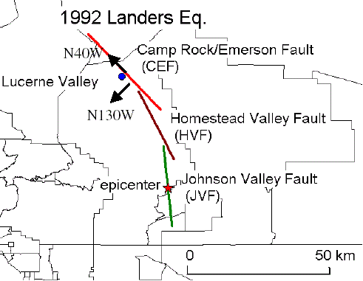
Figure 1: The fault model of 1992 Landers earthquake and the Lucerne valley station
2. Run the Programs
a. Compile and run phs3sQx.f to obtain phase velocities of surface waves.

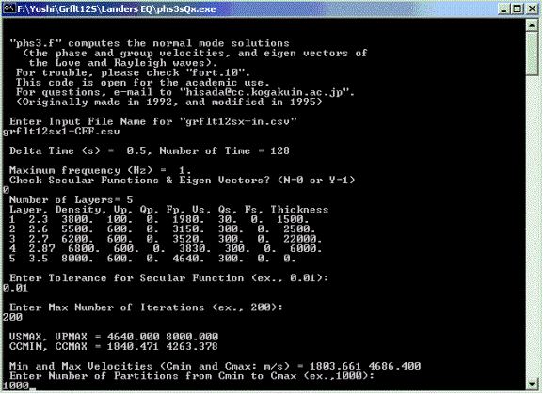
Enter grflt12s1-CEF.csv for the Camp Rock/ Emerson Fault Model.
Enter 0, if you don’t check secular function and eigen vectors of surface waves.
Enter 0.01 or smaller number. Generally the smaller number gives the more accurate results.
Enter 200 or larger number. Generally the larger number gives the more accurate results.
Enter 1000 or larger number. Generally the larger number gives the more accurate results.

To plot phase and group velocities of the Love and Rayleigh waves, use the output csv files, Ldisper.csv and Rdisper.csv, respectively. You can also plot the medium response of the Love and Rayleigh waves, use the output csv files, Lmedres.csv and Rmedres.csv, respectively. See Figure 2, for examples for Love wave.
Figure 2: the dispersion curves (left) and the medium response (right) of the Love wave
b. Compile and run grflt12sx1.f to obtain strong motions in the frequency domain.
See Figure 3 for the coordinate system and fault parameters.

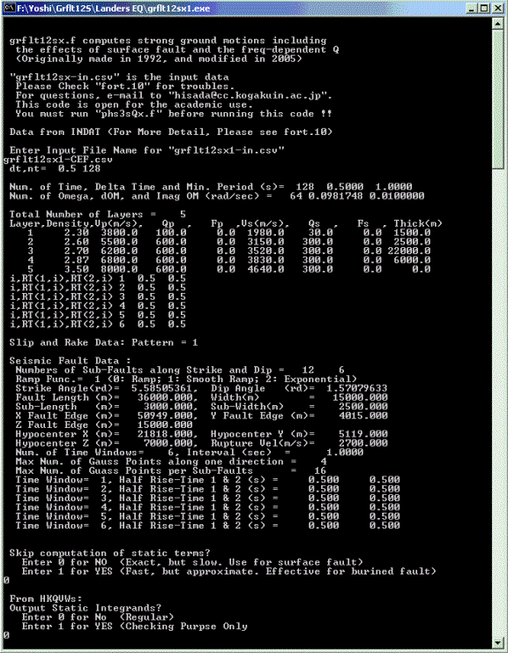
Enter grflt12s1-CEF.csv for the Camp Rock/ Emerson Fault Model.
Enter 0, when you calculate the static Green’s functions.
Enter 0, when you do not check the wave number integration data.

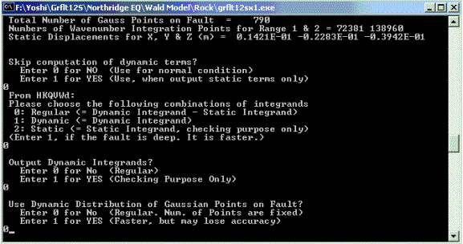
Enter 0, when you calculate the dynamic Green’s functions.
Enter 0, for regular use.
Enter 0, when you do not check the wave number integration data.
Enter 0, for regular use.

Rake Angle
X (North)
Strike Angle
Y (East)
Z (Down)
Free Surface
Hypocenter
Length (L)
Width (W)
Rupture Front
Rupture Velocity (Vr)
X (Source Point)
Y (Observation Station)
Slip Direction
Figure 3: Coordinate system and fault parameters
Dip Angle
Green’s Function
Fault Origin
1
2
3
4
Ns
Ns+1
Ns+2
2Ns
3Ns
NsNd
2Ns+1
Ns-1
5
Ns(Nd-1)+1
Ns(Nd-1)
Strike Direction
Strike Direction
c. Compile and run grfftspx.f to obtain strong motions in the time domain.

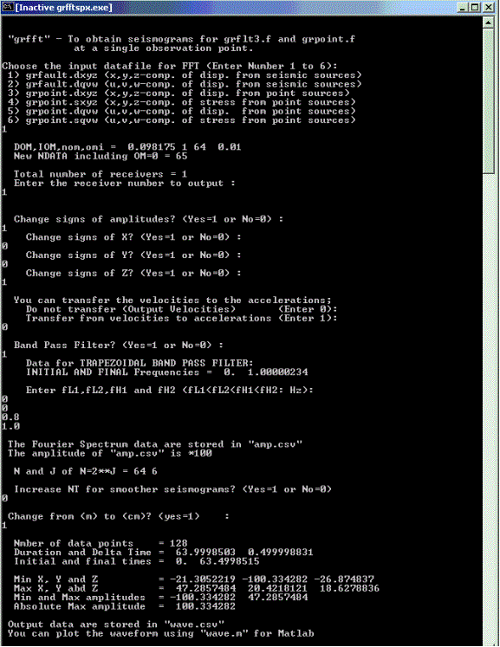
Enter 1, when you plot waves in the X, Y, and Z coordinate system
Choose an observation station number (In this case, Enter 1)
Enter 1, when you change signs of amplitude. Otherwise, enter 0.
Enter 1, when you change the sign of the amplitude. Otherwise, enter 0. In this case, the sign of the Z component is changed (UP is plus).

Enter 0 to plot velocities, or 1 to plot acceleration.
Enter 1 to use the band pass filter. Otherwise 0.
Enter the four corner frequencies of the trapezoidal band pass filter. In this case, a high cut filter tapering from 0.8 Hz to 1.0 Hz is used.
Enter 1, when you use a shorter delta time (dt). Otherwise enter 0. In this case, dt=0.5 s.
Enter 1, when you change the unit of m to that of cm. Otherwise enters 0.

The Fourier amplitude data are stored in amp.csv, and the waveform data are stored in wave.csv.

3. Simulated Results
As an example, Figure 4 shows the velocities at Lucerne valley using grflt12sx1-CEF.csv (Camp Rock/ Emerson Fault Model). Figure 5 shows the displacements, which are integrated at the time domain.
Figure 4. The velocities at Lucerne valley using the Camp Rock/ Emerson fault model.

Figure 5. The displacements at Lucerne valley using the Camp Rock/ Emerson fault model.
4. Comparison of Simulation Results with the Observations
We obtain the final simulated strong motion at the Lucerne valley station by summing up the results from the three fault models (grflt12sx1-CEF.csv, grflt12sx1-HVF.csv, and grflt12sx1-JVF.csv; see Figure 1). Figures 6 and 7 show the comparison between the simulation and the observed records; the records were corrected by Dr. Iwan of Caltech, and can be downloaded from COSMOS Virtual Data Center (http://db.cosmos-eq.org/).

Figure 6. Comparison of velocities at Lucerne valley between the simulation and observation.
Note that the data are rotated in the fault parallel (N40W) and normal (N130W) components (see Figure 1). And the observed records are original, while the simulations are high-cut filtered tapering from 0.8 Hz to 1.0 Hz. As shown in Figures 6 and 7, the fling step and the forward directivity pulse are dominant in the fault parallel and normal components, respectively.

Figure 7. Comparison of displacements at Lucerne valley between the simulations and the observations.

