Table 1. The material properties of the layered half-space
Density (t/m³) | Vp  (km/s) | Vs  (km/s) | Qp | Qs | Thickness  (km)
2.2 | 3.0 | 1.0 | 100 | 50 | 1
2.4 | 4.0 | 2.0 | 150 | 75 | 1
2.5 | 5.0 | 3.0 | 200 | 100 | -

Figure 2.

R

Z

Observation Point

slip

x

y

z

D

U
full range
(r = 0～10,000)

close up range
(r = 0～30)

full range
(r = 0～10,000)

close up range
(r = 0～300)

a) z = 1 m
b) z = 10 m
Figure 3.

R=10 km

$\frac{D}{2}=0\text{.}5$
Figure 4.
m
Exact Solution
Asymptotic Solution

k_{i}
k_{A} k_{r}
B

B’

C’

C

A
D
0
Figure 5.

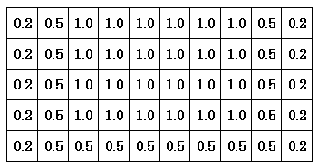
Figure 6.
(a) Fault Model and observation points
(b) Slip Distribution (m)
(c) Slip velocity function

Figure 9.

Figure 11.
(a) Surface Fault (b) Buried Fault

