Application of Grflt-v20.f programs:
1994 Northridge Simulation using the Wald Model (1996)

Dec. 19, 2020 (original Aug. 4, 2006)

0. References
a. The source data of the 1994 Northridge earthquake model
http://pasadena.wr.usgs.gov/office/wald/Landers/bssa.html
http://pasadena.wr.usgs.gov/office/wald/slip_models.html#Landers
We used the source data of Wald and Heaton (Strong Motion) to reproduce the strong motion at the Lucerne Valley Station.
b. Simulation results using this program
2006JEES-paper.pdf (in Japanese)
c. Theories of this program
http://kouzou.cc.kogakuin.ac.jp/Member/Boss/Paper/2003/1154.pdf for the fling step.
http://kouzou.cc.kogakuin.ac.jp/Member/Boss/Paper/95cgf/cgf.html for Green’s function.

1. Input Data
a. Rock Site Model: Rock-in.csv (Data contains 4 stations, U55, U56, SCS7, and SSU)
b. Sediment Site Model: Soil-in.csv (Data contains 10 stations, NHL, SCSe, SYL, RRS, SVA, VNY, U03, SHR, TAR, and U53)
See Figure 1 for the fault model of 1994 Northridge earthquake and the observation stations
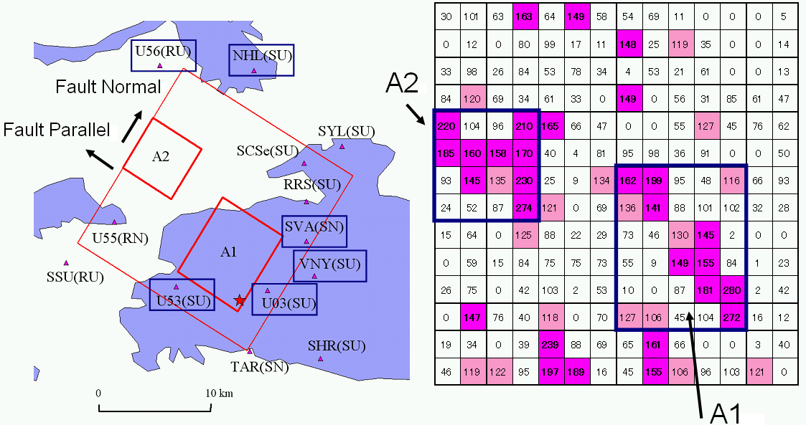
Figure 2: The fault model of 1994 Northridge earthquake and the observation stations
(a) the observation stations and fault plane (b) final slip distribution
2. Run Programs
a. Compile and run phs3sQx-HoV.f to obtain phase velocities of surface waves.
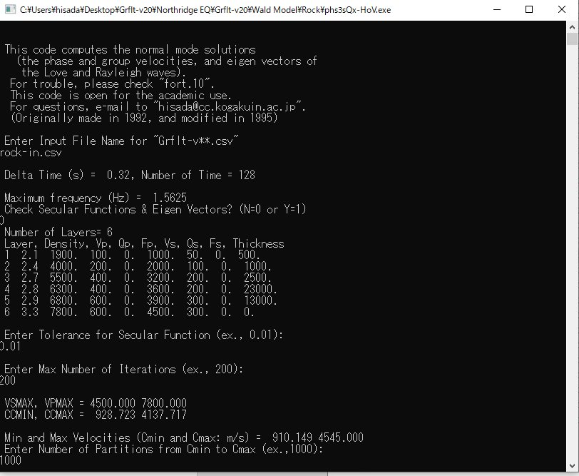
Enter rock-in.csv for the rock model, or soil-in. csv for the sediment model.

Enter 0, if you don’t check secular function and eigen vectors of surface waves.
Enter 0.01 or smaller number. Generally the smaller number gives the more accurate results.
Enter 200 or larger number. Generally the larger number gives the more accurate results.
Enter 1000 or larger number. Generally the larger number gives the more accurate results.

To plot phase and group velocities of the Love and Rayleigh waves, use the output csv files, Ldisper.csv and Rdisper.csv, respectively. You can also plot the medium response of the Love and Rayleigh waves, use the output csv files, Lmedres.csv and Rmedres.csv, respectively. See Figure 2, for examples for Love wave.

Figure 2: the dispersion curves (left) and the medium response (right) of the Love wave
b. Compile and run Grflt-v20.f to obtain strong motions in the frequency domain.
See Figure 3 for the coordinate system and fault parameters.
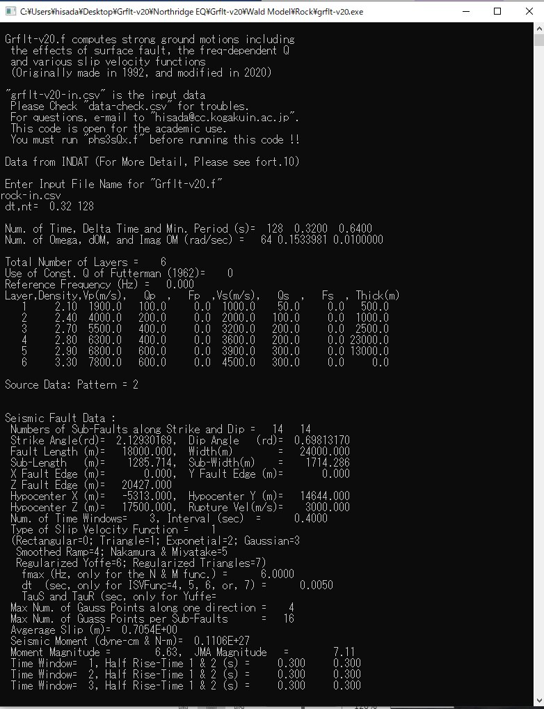
Enter rock-in.csv for the rock model, or soil-in. csv for the sediment model.

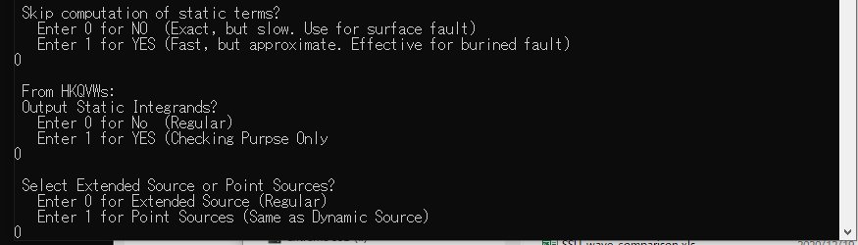
Enter 0, when you calculate the static Green’s functions.

Enter 0, when you do not check the wave number integration data.

Enter 0, when you use extended sources (plane fault), or, enter 1 for point sources specified in the input data.

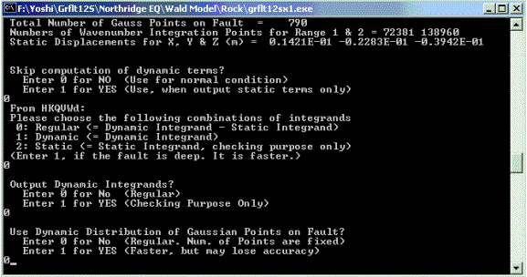
Enter 0, when you calculate the dynamic Green’s functions.
Enter 0, for regular use.
Enter 0, when you do not check the wave number integration data.
Enter 0, for regular use.

Rake Angle
X (North)
Strike Angle
Y (East)
Z (Down)
Free Surface
Hypocenter
Length (L)
Width (W)
Rupture Front
Rupture Velocity (Vr)
X (Source Point)
Y (Observation Station)
Slip Direction
Dip Angle
Green’s Function
Fault Origin
1
2
3
4
Ns
Ns+1
Ns+2
2Ns
3Ns
NsNd
2Ns+1
Ns-1
5
Ns(Nd-1)+1
Ns(Nd-1)
Strike Direction
Strike Direction

Figure 3: Coordinate system and fault parameters

c. Compile and run grfftsx-v20.f to obtain strong motions in the time domain.

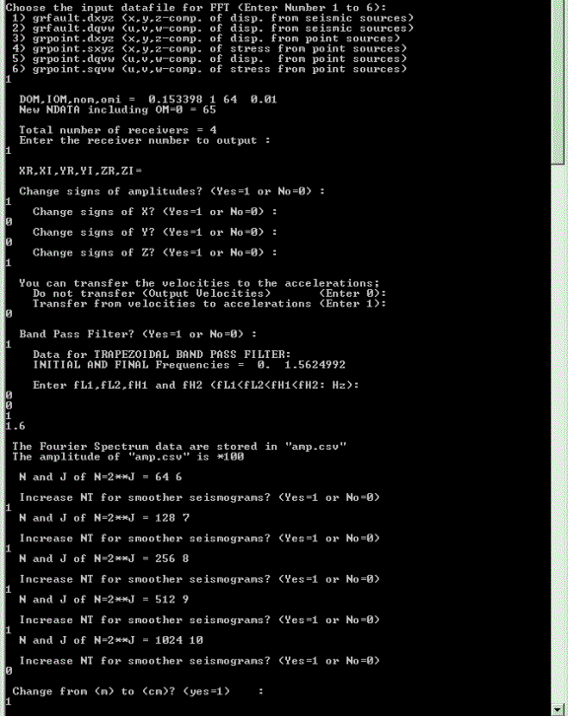
Enter 1, when you plot waves in the X, Y, and Z coordinate system
Choose an observation station number (In this case, Enter 1)
Enter 1, when you change signs of amplitude. Otherwise, enter 0.
Enter 1, when you change the sign of the amplitude. Otherwise, enter 0. In this case, the sign of the Z component is changed (UP is plus).

Enter 0 to plot velocities, or 1 to plot acceleration.
Enter 1 to use the band pass filter. Otherwise 0.
Enter the four corner frequencies of the trapezoidal band pass filter. In this case, a high cut filter tapering from 1.0 Hz to 1.6 Hz is used.
Enter 1, when you use a shorter delta time (dt). Otherwise enter 0. In this case, dt becomes 0.16 s from 0.32 s.
Enter 1, when you change the unit of m to that of cm. Otherwise enters 0.
Enter 1, when you use a shorter delta time (dt). Otherwise enter 0. In this case, dt becomes 0.08 s from 0.16 s.
Enter 1, when you use a shorter delta time (dt). Otherwise enter 0. In this case, dt becomes 0.04 s from 0.08 s.
Enter 1, when you use a shorter delta time (dt). Otherwise enter 0. In this case, dt becomes 0.02 s from 0.04 s.
In this case, dt is 0.02 s.

The Fourier amplitude data are stored in amp.csv, and the waveform data are stored in wave.csv.

3. Simulated Results
As examples, Figures 4 and 5 show the velocities at U55 and U56, respectively, using grflt12sx1r.csv (see Figure 1).

Figure 4. The simulated velocities at U55.

Figure 5. The simulated velocities at U56.

4. Comparison of Simulation Results with the Observations
We compare simulated and observed strong motions, as shown Figures 6 (rock sites) and 7 (sediment sites), The observed records downloaded from PEER Strong Motion Database (http://peer.berkeley.edu/smcat/index.html). All the data are high-cut filtered tapering from 1.0 Hz to 1.6 Hz, and all the horizontal data are rotated in the fault normal (N32E) and parallel (N58W) direction (see Figure 1).

Figure 7. Comparison of velocities at the rock sites between the simulations and the observations.

Figure 8. Comparison of velocities at the sediment sites between the simulations and the observations.

Figure 8. Comparison of velocities at the sediment sites (continued)

Figure 8. Comparison of velocities at the sediment sites (continued)

Figure 8. Comparison of velocities at the sediment sites (continued)

