International Workshop on Long-Period Ground Motion Simulation and Velocity Structures
Earthquake Research Institute, University of Tokyo, Tokyo, November 14-15, 2006

Title (Times New Roman, Bold, 16 Point)
Name A^{1,*}, Name B¹ & Name C²
¹Earthquake Research Institute, University of Tokyo, 1-1-1 Yayoi, Bunkyo-ku, Tokyo 113-0032, Japan; ²University of Tokyo, 7-3-1 Hongo, Bunkyo-ku, Tokyo 113-0032, Japan; *Author for correspondence, e-mail: workshop@taro.eri.u-tokyo.ac.jp

Key words: word1, word2, word3, word4, word5

Abstract
The abstract is 100 words (Times New Roman, 10 point). The deadline is November 8, 2006. Number of the page is 2 or more (no limitation), and we prefer an even page number. The proceedings will be printed in color.

1. Introduction (Times New Roman, Bold, 10 point)
First sentence starts here. Times New Roman (10 point).
The long-period component of seismic ground motion generated by earthquakes causes damage in near-fault regions through source effects such as the directivity effect of rupture propagation and the near-field term of body wave radiation. In addition, the long-period ground motions attenuate slowly with distance due to some path effects, and site effects amplify them in distant basins, so that they can carry destruction to much greater range.
Large-scale structures such as tall buildings and big tanks can resonate with the long-period ground motions because their own natural periods are in the same frequency band. They can even be damaging in some circumstances; the worst example with over 20,000 fatalities in Mexico City at a distance of 400 km from the 1985 Michoacan earthquake. A further example was provided by the 2003 Tokachi-oki earthquake in Hokkaido, Japan. (Koketsu et al., 2005)
Therefore, the simulation of long-period ground motion is one of the most important parts of strong motion evaluation and prediction. The modeling of velocity structures along propagation path and within sedimentary basins also plays an important role. We would discuss these aspects of the long-period ground motion in the workshop. Topics include numerical simulation, velocity structures, source effect, path and site effects, damage and risk, and other related issues on the long-period ground motion.

Table 1. Workshop schedule (Times New Roman, 8 point).

November 14 | Workshop (13:00-17:20) & Reception
November 15 | Workshop (09:10-17:00)
November 16 | Excursion (09:30-17:00)

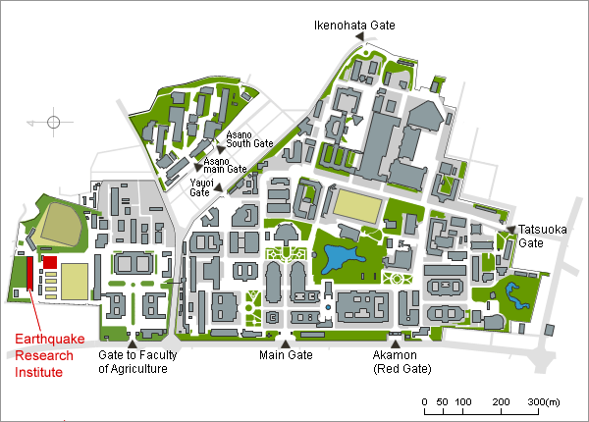
Figure 1. Map to access ERI, Univ. Tokyo. Color figure is acceptable (Times New Roman, 8 point).

Next sentence starts here. Times New Roman (10 point).

2. Method (Times New Roman, Bold, 10 point)
Subtitle 1 (Time New Roman, Italic, 10 point)
Times New Roman (10 point).

y = f (x) (1)

z = f (x, y) (2)

Subtitle 2 (Time New Roman, Italic, 10 point)
Times New Roman (10 point).

3. Discussion and conclusions (Times New Roman, Bold, 10 point)
Times New Roman (10 point).

Acknowledgements
This workshop is supported by SCEC-ERI Cooperation Program and Grant-in-Aid for Scientific Research (Times New Roman, 10 point).

References
Times New Roman (8 point)
Koketsu, K., Hatayama, K., Furumura, T., Ikegami Y. and Akiyama, S., 2005, Damaging long-period ground motions from the 2003 Mw 8.3 Tokachi-oki, Japan, earthquake, Seism. Res. Lett., 76, 67-73.

