International Workshop on Long-Period Ground Motion Simulation and Velocity Structures
Earthquake Research Institute, University of Tokyo, Tokyo, November 14-15, 2006

Long-Period Strong Motion Simulation in Near Fault Region
Hisada Y.^{1,*}
¹Kogakuin Univeristy, Dept. of Architecture, NishiShinjuku 1-24-2, Tokyo 163-8677, Japan
*Author for correspondence, e-mail: hisada@cc.kogakuin.ac.jp

Key words: Near-Fault Strong Motion, Fling Step, Stochastic Source Model, Theoretical Green’s Function

Abstract
The abstract is 100 words (Times New Roman, 10 point). The deadline is November 8, 2006. Number of the page is 2 or more (no limitation), and we prefer an even page number. The proceedings will be printed in color.

1. Introduction (Times New Roman, Bold, 10 point)
We developed a hybrid method for simulating broadband strong motions in layered half-spaces. As for the lower frequency range (less than around 1 Hz), we use the theoretical method by Hisada and Bielak (BSSA, Vol.93, p.1154-1168, 2003), which can simulate accurate near-fault effects, such as the directivity pulses and the fling steps from surface faulting, in layered half-spaces.
As for the high frequency range (more than around 1 Hz), we developed a new method for simulating strong motions in layered half-spaces based on the stochastic source model. In the method, first, we divide a fault plane into sub-faults, and locate Boore’s point source model (amplitude spectra; Boore, 1983) on each sub-faults. As for the phase spectra of the source model, we introduce random and coherent phases at higher and lower frequencies, respectively. The coherent phases are necessary to reproduce coherent waves in near sources, such as the directivity pulses and the fling step at lower frequencies. In addition, we use a hybrid radiation pattern, which is homogeneous and theoretical at higher and lower frequencies, respectively. As for Green’s function, we used the complete Green’s functions in layered half-spaces (Hisada, 1994, 1995), which can generate efficiently strong motions up to very high frequencies. The simulated waves from all the point sources are superposed to follow the omega-square rule. We applied the method to observed records, such as the Landers and Northridge earthquakes, and obtained excellent agreements.

Table 1. Workshop schedule (Times New Roman, 8 point).

November 14 | Workshop (13:00-17:20) & Reception
November 15 | Workshop (09:10-17:00)
November 16 | Excursion (09:30-17:00)

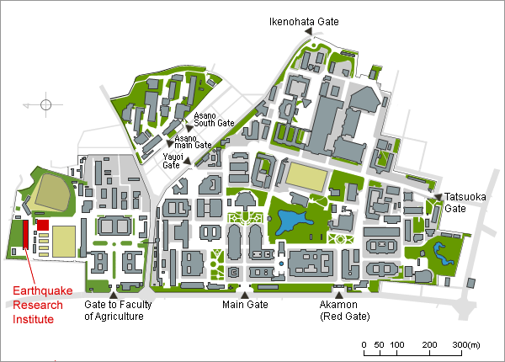
Figure 1. Map to access ERI, Univ. Tokyo. Color figure is acceptable (Times New Roman, 8 point).

Next sentence starts here. Times New Roman (10 point).

2. Method (Times New Roman, Bold, 10 point)
Subtitle 1 (Time New Roman, Italic, 10 point)
Times New Roman (10 point).

y = f (x) (1)

z = f (x, y) (2)

Subtitle 2 (Time New Roman, Italic, 10 point)
Times New Roman (10 point).

3. Discussion and conclusions (Times New Roman, Bold, 10 point)
Times New Roman (10 point).

Acknowledgements
This workshop is supported by SCEC-ERI Cooperation Program and Grant-in-Aid for Scientific Research (Times New Roman, 10 point).

References
Times New Roman (8 point)
Koketsu, K., Hatayama, K., Furumura, T., Ikegami Y. and Akiyama, S., 2005, Damaging long-period ground motions from the 2003 Mw 8.3 Tokachi-oki, Japan, earthquake, Seism. Res. Lett., 76, 67-73.
1. Hisada Y, Bielak J, “A Theoretical Method for Computing Near-Fault Strong Motions in Layered Half-Space Considering Static Offset due to Surface Faulting, with a Physical Interpretation of Fling Step and Rupture Directivity”, Bull. Seism. Soc. Am., 93, 1154-1168, 2003.
2. Wald DJ, Heaton TH, “Spatial and temporal distribution of slip for the 1992 Landers, California earthquake”, Bull. Seism. Soc. Am., 84, 668-691, 1994.
3. Somerville PG, Smith NF, Graves RW, Abrahamson NA, “Modification of empirical strong ground motion attenuation relations to include the amplitude and duration effects of rupture directivity”, Seismological Res. Letter, 68, 199-222. 1997.
4. Abrahamson, N, “Incorporating effects of near fault tectonic deformation into design ground motions”, a presentation sponsored by EERI Visiting Professional Program, hosted by the University at Buffalo, October 26, 2001 (http://mceer.buffalo.edu/outreach/pr/abrahamson.asp).
5. Hisada Y, “An efficient method for computing Green's functions for a layered half-space with sources and receivers at close depths”, Bull. Seism. Soc. Am., 84, 1456 –1472, 1993.
6. Hisada Y, “An efficient method for computing Green's functions for a layered half-space with sources and receivers at close depths (Part 2)”, Bull. Seism. Soc. Am., 85, 1080-1093, 1995.
7. Greenfield RJ, Comments on "An efficient method for computing Green's functions for a layered half-space with sources and receivers at close depths" by Y. Hisada, Bull. Seism. Soc. Am., 85, 1523-1524, 1995.
8. Iwan WD, Corrected Accelerogram, 1992 Landers earthquake, COSMOS Virtual Data Center (http://db.cosmos-eq.org/).
9. Honda R, Yomogida K, “Effects of a soft surface layer on near-fault static and dynamic displacements”, Geophys. J. Intern., 154, 441-462, 2003.

