An Efficient Method for Simulating Near-Fault Strong Motions
at Broadband Frequencies
in Layered Half-Spaces

Yoshiaki Hisada
(Kogakuin University)

Abstract

・We developed a hybrid method for simulating broadband strong motions in layered half-spaces.
・As for the lower frequency range (less than around 1 Hz), we use the theoretical method by the modified k-squared model (Hisada, 2001) and Hisada and Bielak (BSSA, Vol.93, p.1154-1168, 2003), which can simulate accurate near-fault effects, such as the directivity pulses and the fling steps from surface faulting, in layered half-spaces.
・As for the high frequency range (more than around 1 Hz), we developed a new method for simulating strong motions in layered half-spaces based on the stochastic source model.
・We checked the validation of the method by applying to the strong ground motion for the 1994 Northridge earthquake.

Modified K-2 model（Hisada, 2000）
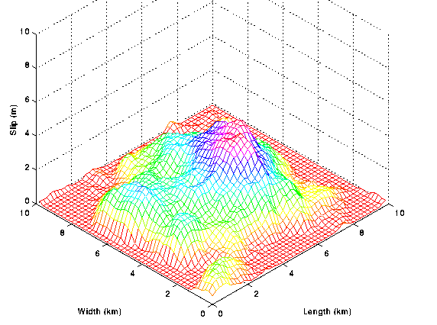
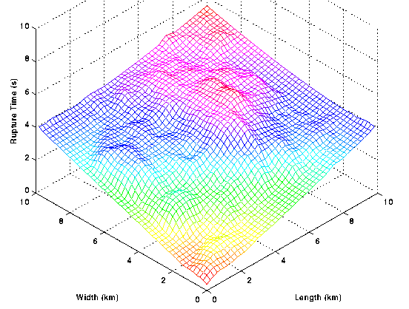
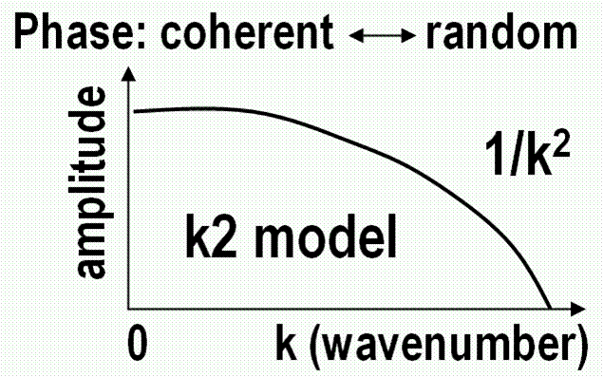
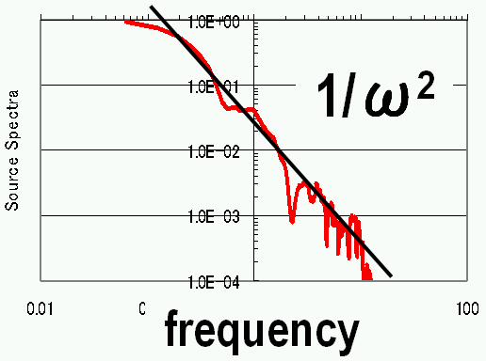
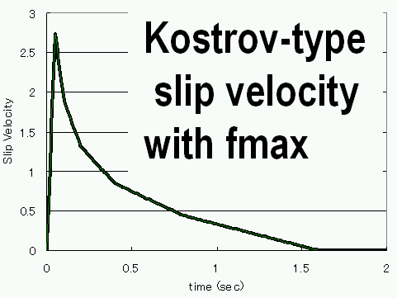
Source spec.: ω² model
+
+
Method at Low Frequencies (Hisada and Bielak, 2003)

$U_{k}(Y;ω)=\int{T_{\text{ik}}^{D}(X,Y;ω)D_{i}(X;ω)}dΣ$Conventional Representation Theorem
$T_{\text{ik}}^{D}$$T_{\text{ik}}^{D}$where is the dynamic Green’s function of layered half-spaces, which shows near-singular behaviors when a observation point Y is close to the fault plane X.
singular behaviors of

$U_{k}(Y;ω)=\int{\left\{T_{\text{ik}}^{D}(X,Y;ω)−T_{\text{ik}}^{S}(X,Y)\right\}D_{i}(X;ω)}dΣ+\int{T_{\text{ik}}^{S}(X,Y)D_{i}(X;ω)}dΣ$New Representation Theorem for Near-Source Ground Motion
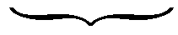
Dynamic Term (attenuation→1/r～1/√r)
Static Term (attenuation→1/r²)

where the dynamic term does not have singularities, thus its fault integration can be easily carried out. On the other hand, although the integration of the static term does require densely distributed points to capture the singular behavior of the static Green’s function, it shows a same value for all the frequencies, and needs to be performed only once.

1992 Landers Earthquake (Wald and Heaton, 1994)

Density  (g/cm³) | Vp (km/s) | Qp | Vs (km/s) | Qs | Thickness  (km)
2.3 | 3.8 | 100 | 198 | 30 | 1.5
2.6 | 5.5 | 600 | 315 | 300 | 2.5
2.7 | 6.2 | 600 | 352 | 300 | 22.0
2.87 | 6.8 | 600 | 383 | 300 | 6.0
3.5 | 8.0 | 600 | 464 | 300 | 0.0

Slip Model
Comparison between Simulations and Observations

Layered Structure Model (Wald and Heaton, ’94)

(2 – 13 second)

at LUC

Comparison between Simulations and Observations
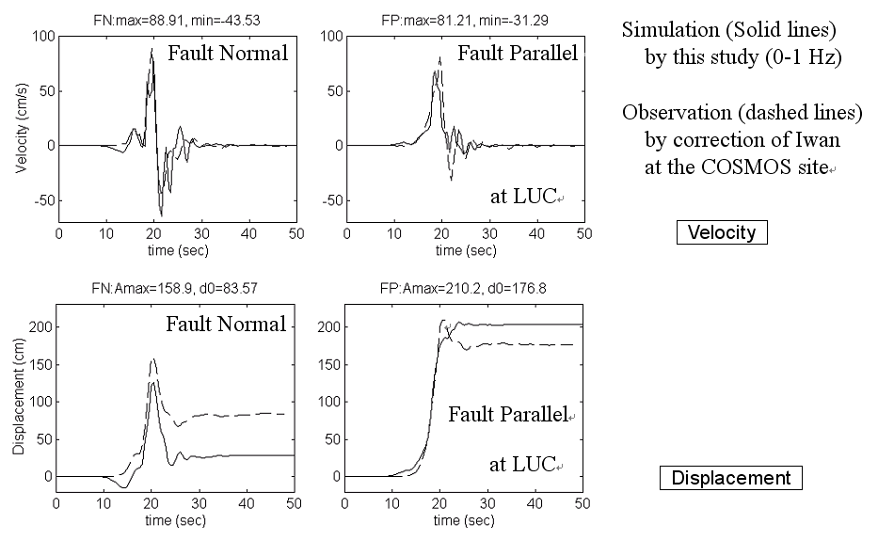

Method at High Frequencies (Hisada, 2005)

Formulation of Moment Rate Function of Sub-Fault (Ohnishi and Horike, 2000)
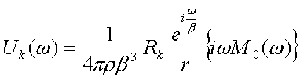
・Far-Field Displacement in Homogeneous Full-Space
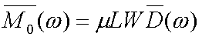

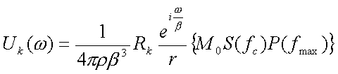
・Stochastic Source Model (Boore, 1983)

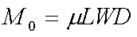

When we equate the rectangle parts, we get the omega-squared Fourier Amplitude of a stochastic moment (rate) function.
$\overline{M_{0}}(ω)=\frac{1}{iω}M_{0}S(F_{C})P(f_{\text{max}})$

Hybrid Phase Spectra of Moment Rate Function (Hisada, 2004)
・Omega-Squared Fourier Amplitude with Zero Phases
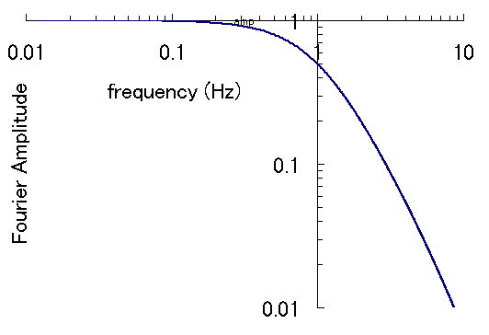
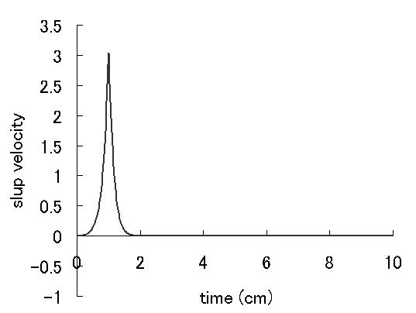
Moment Rate
Function
(Duration is 1/fc s)

Fourier Amplitude
fc=1 Hz
fmax=10 Hz
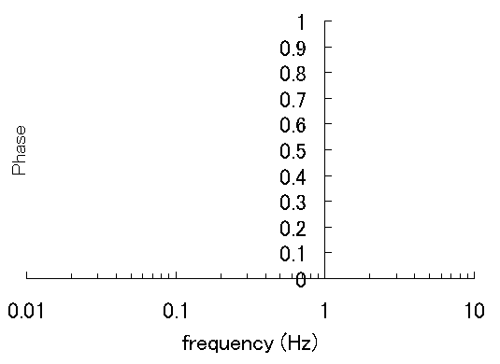
Fourier Phases

Moment Function
Zero Phases

・Omega-Squared Fourier Amplitude with Zero Phases at Lower Frequencies and Random phases at higher Frequencies
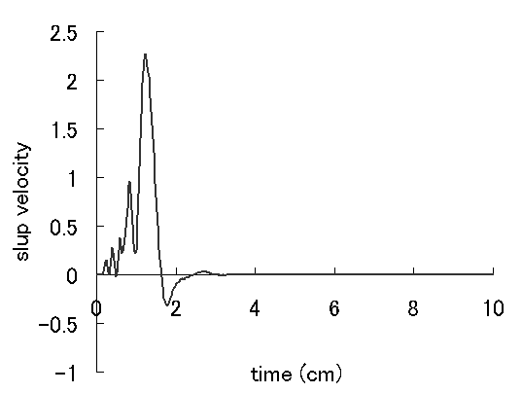
Moment Rate
Function

Fourier Amplitude
fc=1 Hz
fmax=10 Hz

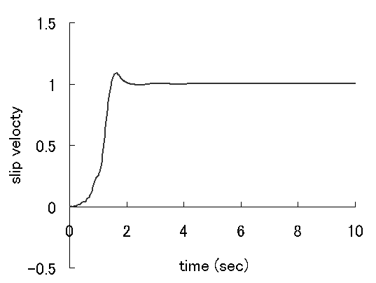
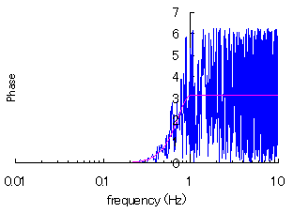
Fourier Phases

Moment Function
Zero Phases

Introduction of Theoretical Green’s Function of Layered Half-Space into Stochastic Source Model (Hisada, 2005)
・Representation Theorem for a Sub Fault
$U_{k}(ω)=\int{T_{\text{ik}}D_{i}dΣ}≃T_{\text{ik}}\frac{\overline{\text{Mo}}(ω)}{μ}$$T_{\text{ik}}$
: Traction Green’s Function of
Layered Half-Space

Introduction of Broad-Band Radiation Pattern (Hisada, 2005)
- Theoretical Radiation Pattern at Lower Frequencies
- Homogeneous Radiation Pattern at Higher Frequencies
- Radiation Coefficients: P Wave=0.52 & S Wave=0.63 (Boore and Boatwrite, 1984)
- Homogenous Point Source Model for P Wave: Explosive Source
- Homogenous Point Source Model for S Wave: SH-Type Double-Couple Source

Superposition of Synthetic Waves from Sub-Faults

(Hisada, 2005)
Frequency (Hz)
Coefficient for Amplitude
Correction (N=25)

- At f (Frequency) = 0, we superpose the synthetic waves from sub-faults linearly, to conserve the total seismic moment.
- At higher frequencies (than fr), we superpose the synthetic waves from sub-faults linearly, and multiply the square root of N (the total number of sub-faults) to conserve the omega-squared source spectra.
- At frequencies between 0 and fr, we superpose the synthetic waves from sub-faults linearly, and multiply a coefficient between 1 at f = 0 Hz and the square root of N at f = fr Hz, showing the right figure.

Numerical Example (Source and Structure Model)
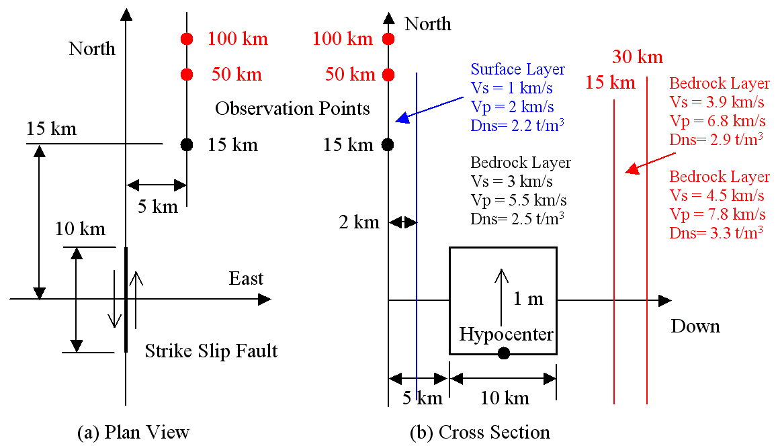

Results for the Example (Sediment Model)

Homogeneous
Full Space x 2
Homogeneous
Full Space x 2

Layered Half-Space
Layered Half-Space

Homogeneous
Full Space x 2
Homogeneous
Full Space x 2

Layered Half-Space
Layered Half-Space

Fault Normal Component
Fault Parallel Component

Results for the Example (Crustal Model)

Fault Normal Component
Fault Parallel Component
Homogeneous
Full Space x 2
Homogeneous
Full Space x 2
Homogeneous
Full Space x 2
Layered Half-Space
Layered Half-Space
Layered Half-Space
Layered Half-Space

Homogeneous
Full Space x 2

Application to the 1994 Northridge Earthquake

Source Model (Wald et al, 1996)
A2
Fault Normal
Fault Parallel

A1
Fault Model and Strong Motion
Recording Stations
Slip Distribution and Simplified Asperities

Regional Velocity Structure (Wald et al, 1996)

Methods

・For Low Frequencies (f < 1 Hz)

1) Original Source Model by Wald et al. (1996)

2) Simplified Source Model with Two Asperities with Constant Rupture Velocity (Vr = 3 km/s)

3) Simplified Source Model with Two Asperities with Variable Rupture Velocity (Vr = 3 km/s + Random Delay at Sub-Fault) to represent the k-squared model

・For High Frequencies (f > 1 Hz)

1) Simplified Source Model with Two Asperities: ⊿σ=200 bar at A1, ⊿σ=100 bar at A2, and ⊿σ=50 bar in the other areas

2) Simplified Source Model without Asperities with ⊿σ=100 bar on the whole fault plane

Comparison between Synthetic Velocities using the Original Wald Model for Low Frequencies (less than 1 Hz), and Observed Velocities

Comparison between Synthetic Velocities using the Original Wald Model for Low Frequencies (less than 1 Hz), and Observed Velocities

Comparison between Synthetic and Observed Velocities using the Simplified Asperity Model for Low Frequencies (less than 1 Hz)

Comparison between Synthetic and Observed Velocities using the Simplified Asperity Model for Low Frequencies (less than 1 Hz)

Comparison between Synthetic and Observed Velocities using the Simplified Asperity Model for high Frequencies (higher than 1 Hz)

Comparison between Synthetic and Observed Velocities using the Simplified Asperity Model at high Frequencies (higher than 1 Hz)

Summary

- We applied the hybrid method using simplified asperities to the strong ground motion for the 1994 Northridge earthquake.
- As for the low frequency range, the simplified asperity model with variable rupture velocity simulates successfully not only forward directivity pulses, but also complex waveforms near epicenter areas.
- As for the high frequency range, the models between the simplified asperity model (high stress drops) and the no-asperity model (constant stress drop) do not show distinct differences. For the engineering applications, the latter (no-asperity model) may be better, because the results show less spatial variability than the asperity model.

