Application of Grflto2x (High-Freq Method, Excel-Ver.) programs:
1992 Landers EQ Simulation using the Wald and Heaton Model (1994)

Y. Hisada, Aug. 21, 2006

0. References
a. The source data of the 1992 Landers earthquake model
http://pasadena.wr.usgs.gov/office/wald/Landers/bssa.html
http://pasadena.wr.usgs.gov/office/wald/slip_models.html#Landers
We used the source data of Wald and Heaton (Combined Model) to reproduce the strong motion at the Lucerne Valley Station.
b. Simulation results using this program
Not available yet.
c. Theories of this program
http://kouzou.cc.kogakuin.ac.jp/Member/Boss/Paper/95cgf/cgf.html for Green’s function.
http://kouzou.cc.kogakuin.ac.jp/Member/Boss/Paper/2005/JEEA2004.pdf for Phase Spectra (in Japansese)
Paper for the detail theory is not yet available.

1. Input Data
As shown in Figure 1, the 1992 Landers earthquake model consists of the following three fault models. In order to obtain the strong motion at the Lucerne valley station, the three results have to be superposed.
a. grflto2x-CEF.csv: Camp Rock/ Emerson Fault Model
b. grflto2x-HVF.csv: Homestead Valley Fault Model
c. grflto2x-JVF.csv: Johnson Valley Fault Model
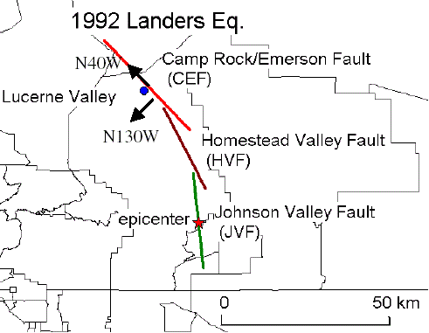
Figure 1: The fault model of 1992 Landers earthquake and the Lucerne valley station
2. Run the Programs
a. Compile and run phs3x.f to obtain phase velocities of surface waves.

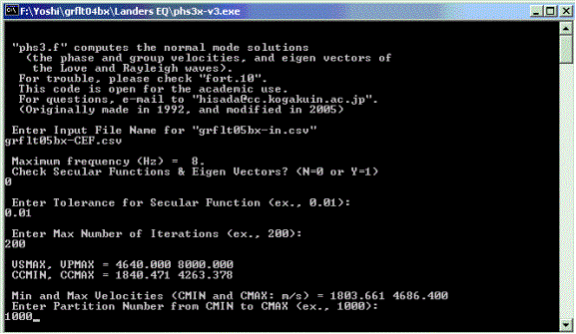
Enter grflto2x-CEF.csv for the Camp Rock/ Emerson Fault Model.
Enter 0, if you don’t check secular function and eigen vectors of surface waves.
Enter 200 or larger number. Generally the larger number gives the more accurate results.
Enter 1000 or larger number. Generally the larger number gives the more accurate results.
Enter 0.01 or smaller number. Generally the smaller number gives the more accurate results.

To plot phase and group velocities of the Love and Rayleigh waves, use the output csv files, Ldisper.csv and Rdisper.csv, respectively. You can also plot the medium response of the Love and Rayleigh waves, using the output csv files, Lmedres.csv and Rmedres.csv, respectively. See Figure 2, for examples for Love wave.
Figure 2: the dispersion curves (left) and the medium responses (right) of the Love wave
b. Compile and run grflto2x.f to obtain strong motions in the frequency domain.
See Figure 3 for the coordinate system and fault parameters.
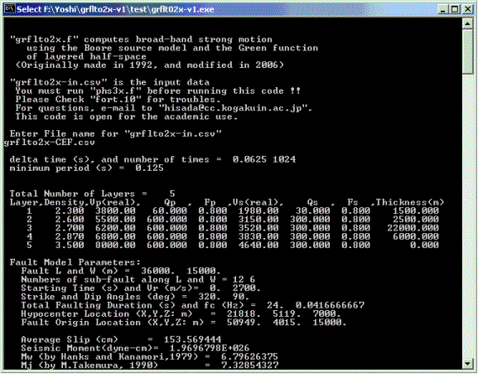

Enter grflto2x-CEF.csv for the Camp Rock/ Emerson Fault Model.

Rake Angle
X (North)
Strike Angle
Y (East)
Z (Down)
Free Surface
Hypocenter
Length (L)
Width (W)
Rupture Front
Rupture Velocity (Vr)
X (Source Point)
Y (Observation Station)
Slip Direction
Figure 3: Coordinate system
and fault parameters
Dip Angle
Green’s Function
Fault Origin
1
2
3
4
Ns
Ns+1
Ns+2
2Ns
3Ns
NsNd
2Ns+1
Ns-1
5
Ns(Nd-1)+1
Ns(Nd-1)
Strike Direction
Strike Direction
c. Compile and run grfftpx.f to obtain strong motions in the time domain.
The Fourier amplitude data are stored in amp.csv, and the waveform data are stored in wave.csv.
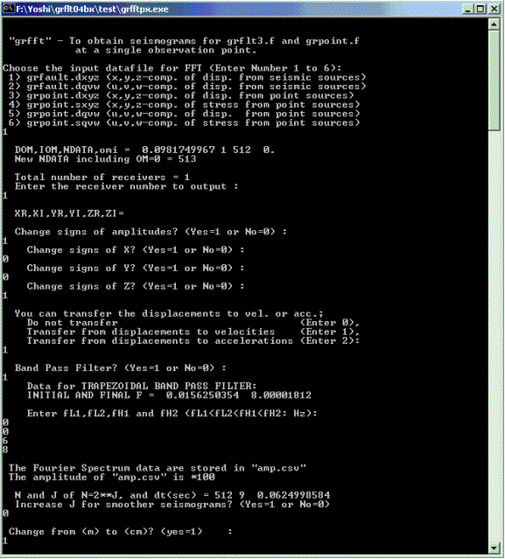
Enter 1, when you plot waves in the X, Y, and Z coordinate system
Choose an observation station number (In this case, Enter 1)
Enter 1, when you change signs of amplitude. Otherwise, enter 0.
Enter 1, when you change the sign of the amplitude. Otherwise, enter 0. In this case, the sign of the Z component is changed (UP is plus).

Enter 1 to plot velocities, 0 to plot acceleration, or 2 to plot accelerations.
Enter 1 to use the band pass filter. Otherwise 0.
Enter the four corner frequencies of the trapezoidal band pass filter. In this case, a high cut filter tapering from 6 Hz to 8 Hz is used.
Enter 1, when you use a shorter delta time (dt). Otherwise enter 0. In this case, dt=0.0625 s.
Enter 1, when you change the unit of m to that of cm. Otherwise enters 0.

3. Simulated Results
As an example, Figures 4 and 5 show the velocities and the accelerations simulated at Lucerne valley using grflto2x-CEF.csv (Camp Rock/ Emerson Fault Model). The simulations are high-cut filtered tapering from 6 Hz to 8 Hz
Figure 4. The velocities at Lucerne valley using the Camp Rock/ Emerson fault model.
Figure 5. The accelerations at Lucerne valley using the Camp Rock/ Emerson fault model.
4. Comparison of Simulation Results with the Observations
We obtain the final simulated strong motion at the Lucerne valley station by summing up the results from the three fault models (grflto2x-CEF.csv, grflto2x-HVF.csv, and grflto2x-JVF.csv; see Figure 1). Figure 6 and Figures 7, 8 and 9 show the comparisons of Fourier amplitudes and waves between the simulations and the observed records; the records were corrected by Dr. Iwan of Caltech, and can be downloaded from COSMOS Virtual Data Center (http://db.cosmos-eq.org/). Note that the data are rotated in the fault parallel (N40W) and normal (N130W) components (see Figure 1). And all the waves are high-cut filtered tapering from 6 Hz to 8 Hz.

Figure 6. Comparison of Fourier accelerations at Lucerne valley between the simulation and observation.
Even though this simulation is the very first try without considering realistic high-frequency source parameters (e.g., distributions of stress drops and fmax), and soil structures (especially, surface soil layers), the comparison between the simulation and observation show a good agreement at broad frequencies. The smaller amplitudes at high-frequencies (see Figure 6) are probably caused by neglecting surface layers. The shorter duration in accelerations (see Figure 7) are probably caused by shorter durations of faulting process model, in addition to scattering of seismic waves and lack of surface layers. Note that, even though this method is for high-frequency simulations, the simulated velocities and displacements show relatively good agreements with the observation, especially the directivity pulse in the fault normal component, and the fling step in the fault parallell component. These indicate the validity of Hisada’s phase spectra for the moment-rate functions (Hisada, 2005), where coherent (zero) phases and random phases are used at lower- and higher- frequencies, respectively.
Figure 7. Comparison of accelerations at Lucerne valley between the simulation and observation.

Figure 8. Comparison of velocities at Lucerne valley between the simulation and observation.

Figure 9. Comparison of displacements at Lucerne valley between the simulations and the observations.

